**Scenario**

The café currently uses a single Amazon Elastic Compute Cloud (Amazon EC2) instance to host its web server, database, and application code.

Meanwhile, the café business has grown. The order history that is stored in the database provides valuable business information that the café staff doesn't want to lose. Martha uses the data for accounting, and Frank looks at it occasionally to plan how many of each dessert type he should bake.

Sofía has additional concerns. The database must be consistently upgraded and patched, and she doesn’t always have time to do these tasks. Also, administering the database is a specialized skill. Training others to do database administration isn’t something that she wants to spend time on. Meanwhile, Sofía is also concerned that the café isn’t doing data backups as often as they should.

Finally, Martha also wants to reduce labour costs that are associated with the technical learning investment that's needed to manage the database.

* Create an RDS database instance.
* Export data from a MariaDB database by using mysqldump.
* Connect a SQL client to an RDS database.
* Migrate data from a MariaDB database that runs on an EC2 instance to an RDS database instance.
* Configure a web application to use the new RDS database instance for data storage

**Screenshots**

*Created a database instance under Amazon RDS*

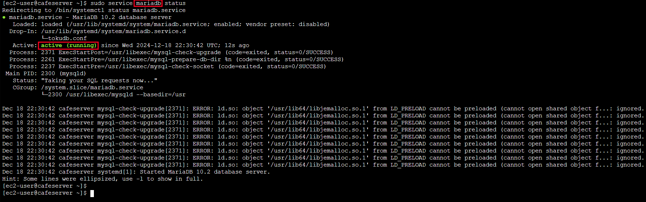

*Checking the status of MariaDB inside EC2 instance*

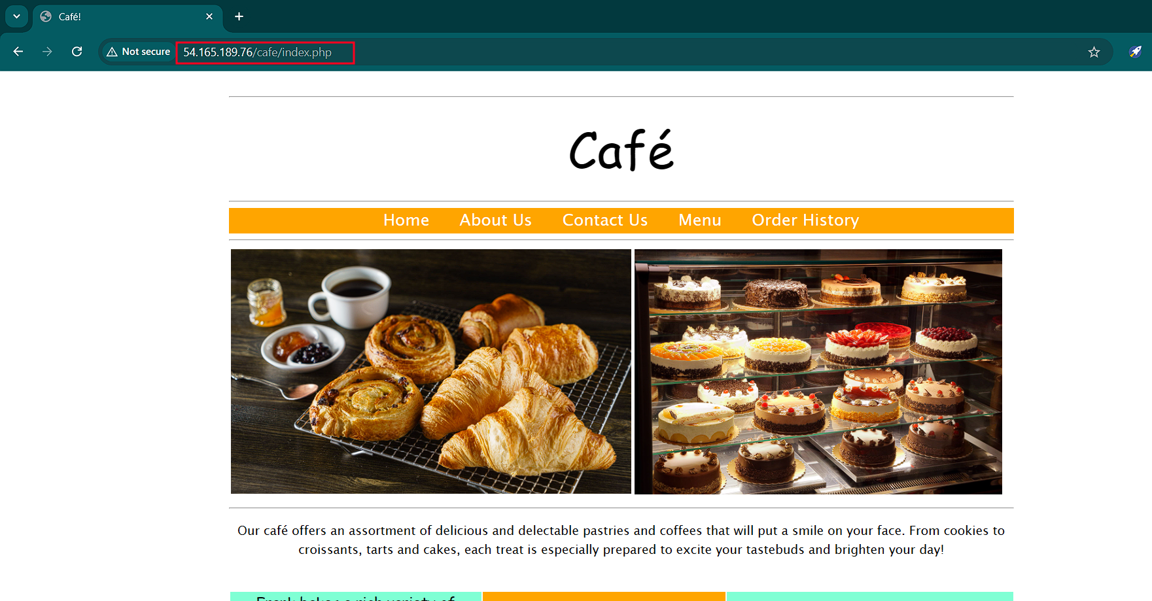

*Webpage details*

*Reviewing Databases and checking the tables inside of café_db*

*Taking backup of the café_db database*

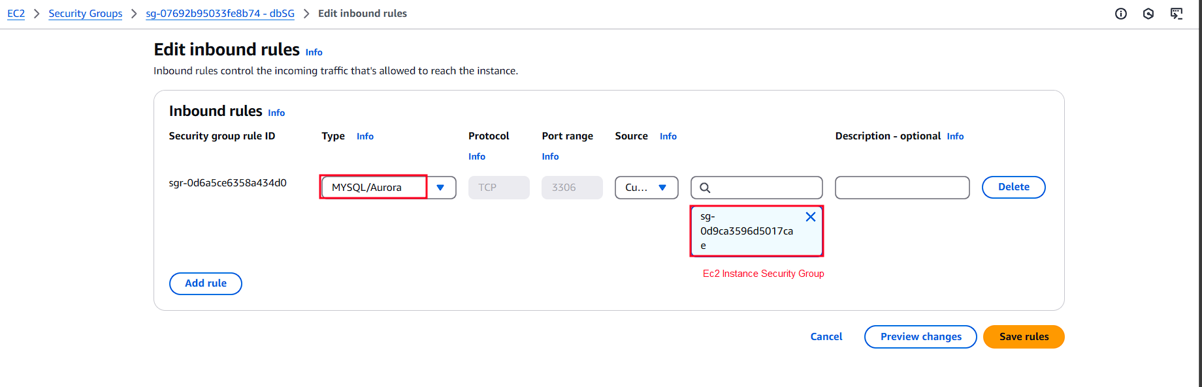

*Modifying inbound rule to allow port 3306 and giving source as security group of EC2 instance*

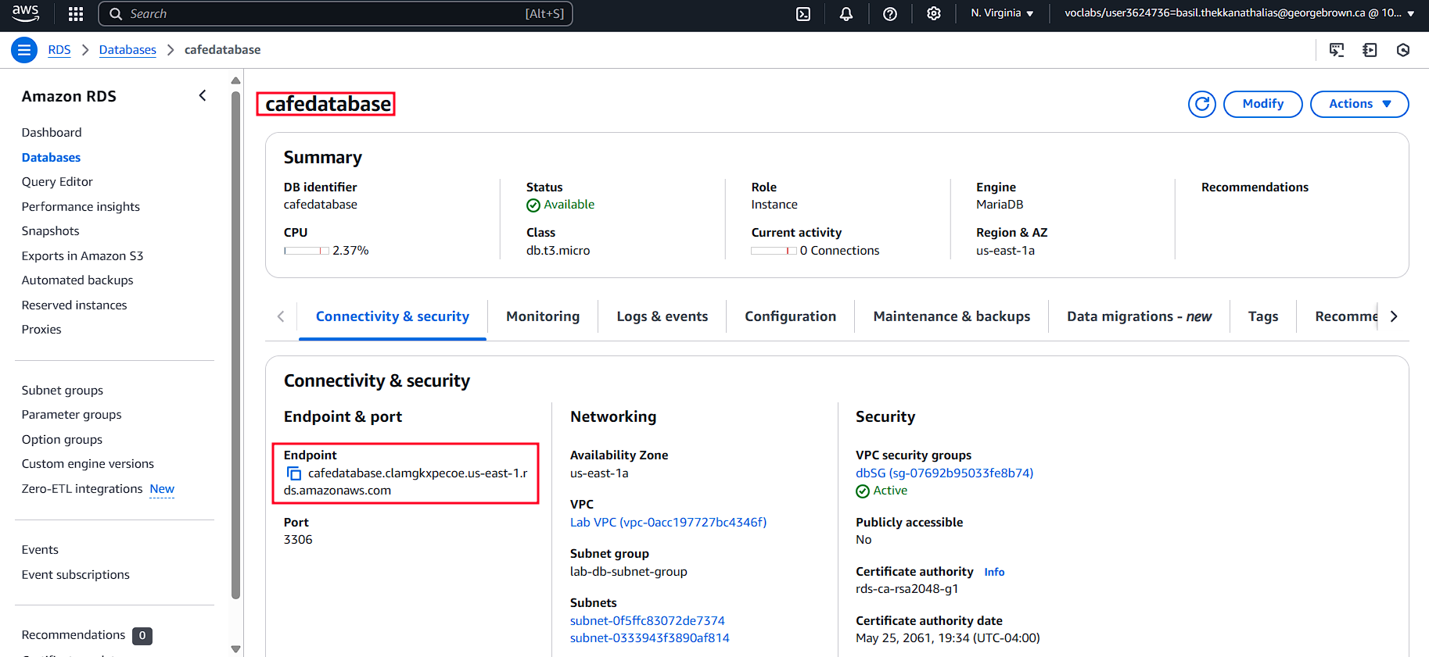

*Copying endpoint of RDS database*

*3306 port is open*

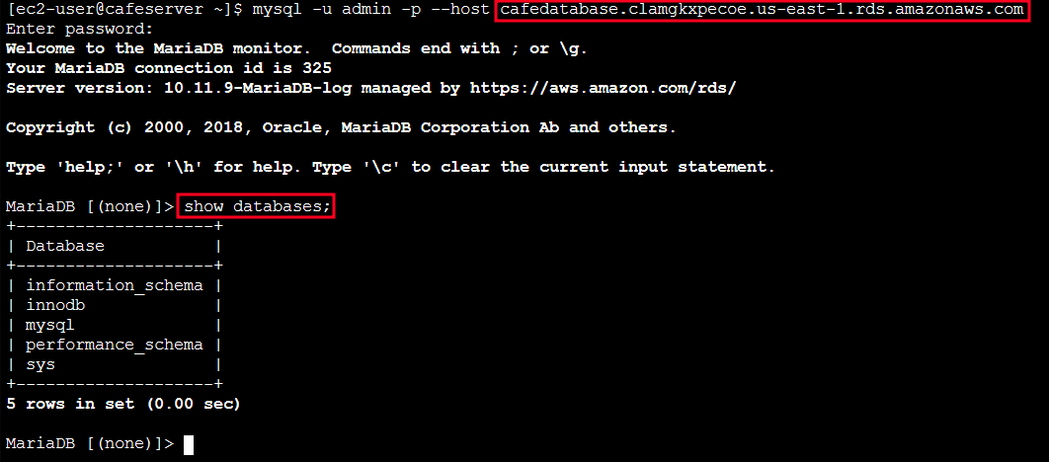

*Connecting to RDS database and reviewing the available databases*

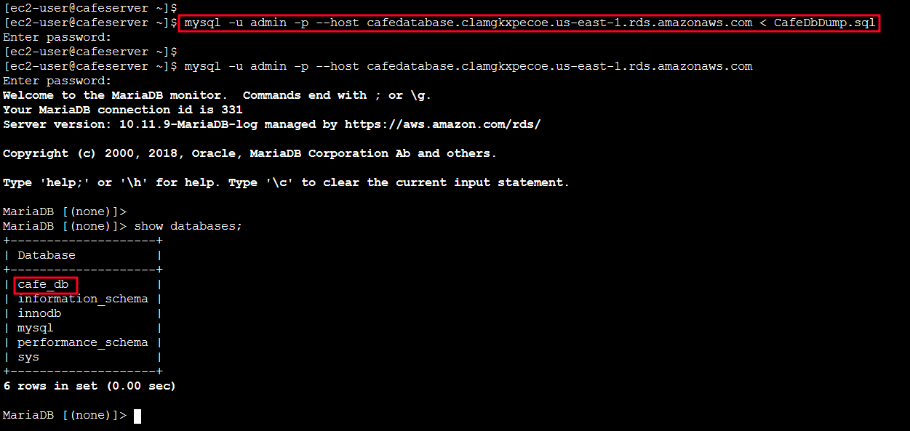

*Importing the Café_db backup to RDS Database*

*Secrets Manager details*

*Stopping the MariaDB service inside the EC2 instance*



*Accessing the webpage*

*Architecture details before migration*

*Architecture details after migration*

**Conclusion**

* Created an RDS database instance
* Exported data from a MariaDB database by using mysqldump
* Connected a SQL client to an RDS database.
* Migrated data from a MariaDB database that runs on an EC2 instance to an RDS database instance
* Configured a web application to use the new RDS database instance for data storage